 | 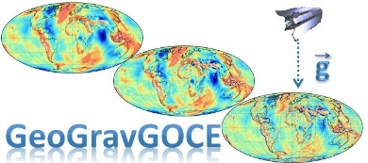 | Ref: Con. Nr. 3488  Version: 1.0  Date: 1.24.2020  Page: 1/22

GeoGravGOCE

Geoid and Gravity Field Modelling by GOCE Satellite Gradients
and Terrestrial Data

WP xx: xxxxxxxxxxxxxxxxxxx
TSKxxxx: xxxxxxxxxxxxxxxxxxxx
DELIVERABLE
DLxxxx.x: xxxxxxxxxxxxxxxxxxxxxxxxxxx

Distribution List
HFRI |  | AUTH Research Committee
HFRI DL Office | 1 | RC AUTH DL Office | 1

Table of Contents

Abstract 7
List of Figures 9
List of Tables 11
Acronyms 13
- GeoGravGOCE xxxxxxxxxxxxxxxxxxx 15
1.1 Heading Level1 15
1.2 Heading Level1 15
1.2.1 Heading Level2 15
1.3 Concluding remarks 16

Abstract

This report refers to management activities of the GeoGravGOCE project xxxxxxxxxxxxxxx xxxxxxxxxxxxxxxxxxx xxxxxxxxxxxxx This report refers to management activities of the GeoGravGOCE project xxxxxxxxxxxxxxx xxxxxxxxxxxxxxxxxxx xxxxxxxxxxxxx This report refers to management activities of the GeoGravGOCE project xxxxxxxxxxxxxxx xxxxxxxxxxxxxxxxxxx xxxxxxxxxxxxx This report refers to management activities of the GeoGravGOCE project xxxxxxxxxxxxxxx xxxxxxxxxxxxxxxxxxx xxxxxxxxxxxxx This report refers to management activities of the GeoGravGOCE project xxxxxxxxxxxxxxx xxxxxxxxxxxxxxxxxxx xxxxxxxxxxxxx.

List of Figures

Figure 1: Sample Figure. 15

List of Tables

Table 1: Sample Table. 15

Acronyms

DL Deliverable
EFRF Earth Fixed Reference Frame
ES Earth Surface
FIR Finite Impulse Response
GGMs Global Geopotential Models
GRF Gradiometer Reference Frame
GSRT General Secretariat for Research and Technology
HFRI Hellenic Foundation for Research and Innovation
IIR Infinite Impulse Response
IRF Inertial Reference Frame
LNOF Local North Oriented Frame
LS Least Squares
LSC Least Squares Collocation
MC Monte Carlo
MIMOST Multiple Input Multiple Output System Theory
MO Mean Orbit
MRA Multi-Resolution Approximation
PSD Power Spectral Density
RTM Residual Terrain Model
SA Simulated Annealing
SGG Satellite Gravity Gradiometry
SISOS Single Input Single Output System
TSK Task
WL Wavelet
WP Work Package
WPS Work Package Structure
w.r.t. with respect to

GeoGravGOCE xxxxxxxxxxxxxxxxxxx

Heading Level1
During the GeoGravGOCE project, xxxxxxxxxxxxxxxxxxxxxxxxxxxxxxx xxxxxxxxxxxxxxxxxxxxxxxxxxx xxxxxxxxxxx xxxxxxxxxxxxxxxxxxxxx xxxxxx xxxxxxxxx xxxxxxxxx xxxxxxxxxxx cxxxxxxxxxxxxxxx

Heading Level1
During the GeoGravGOCE project, xxxxxxxxxxxxxxxxxxxxxxxxxxxxxxx xxxxxxxxxxxxxxxxxxxxxxxxxxx xxxxxxxxxxx xxxxxxxxxxxxxxxxxxxxx xxxxxx xxxxxxxxx xxxxxxxxx xxxxxxxxxxx cxxxxxxxxxxxxxxx
Table 1: Sample Table.

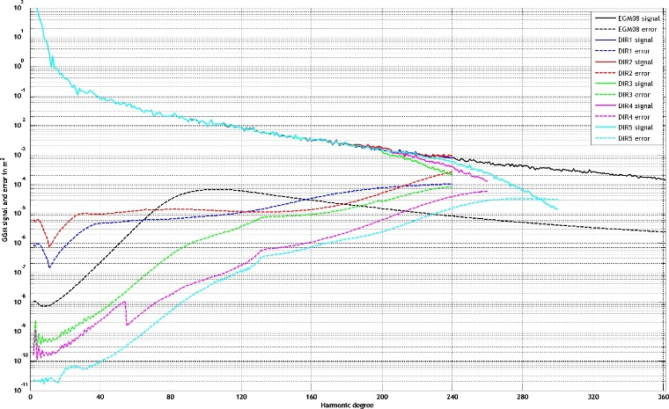
Figure 1: Sample Figure.

Heading Level2
During the GeoGravGOCE project, xxxxxxxxxxxxxxxxxxxxxxxxxxxxxxx xxxxxxxxxxxxxxxxxxxxxxxxxxx xxxxxxxxxxx xxxxxxxxxxxxxxxxxxxxx xxxxxx xxxxxxxxx xxxxxxxxx xxxxxxxxxxx cxxxxxxxxxxxxxxx

Concluding remarks
Prof. Tziavos concluded the kick-off meeting by wishing everyone a good project start, fruitful cooperation and timely delivery of the DLs. The next project meeting (1st semi-annual meeting) will take place during the first week of June 2020.

